For the Attention of: Rebecca Owens – Case Officer
Merthyr Tydfil County Borough Council

[By Email: planning@merthyr.gov.uk]

28th June 2022

Dear Ms Owens

PLANNING APPLICATION: P/22/0118

Provision of access and car parking, CCTV cameras, storage container, dug outs, fencing with associated access gates and pitch side rail.; Land At Pavilion And Changing Rooms, Pantyffyn Road, Penyard

Thank you for your consultation notification of 15 June 2022 seeking the views of The Coal Authority on the above planning application.

The Coal Authority is a non-departmental public body sponsored by the Department of Business, Energy & Industrial Strategy. As a statutory consultee, The Coal Authority has a duty to respond to planning applications and development plans in order to protect the public and the environment in mining areas.

The Coal Authority Response: Material Consideration

I have reviewed the site location plans and the proposals and supporting information submitted and available to view on the LPA website and can confirm that the site falls within the defined Development High Risk Area.

The Coal Authority records indicate that the site lies in an area of probable unrecorded underground coal mine workings at shallow depth. If shallow workings are present then those pose a potential risk to surface stability and public safety. Our records also show that the north western boundary of the site abuts a site from which coal has been removed by surface mining methods.

As you will be aware, the Coal Authority’s general approach in cases where development is proposed within the Development High Risk Area is to recommend that the applicant obtains coal mining information for the application site and submits a Coal Mining Risk Assessment to support the planning application.

However, when considering the nature of this particular development proposal, it does not appear that the provision of access and car parking, CCTV cameras, storage container, dug outs, fencing with associated access gates and pitch side rail will require substantial foundations or earthworks. On this basis we do not consider that requiring a Coal Mining Risk Assessment would be proportionate to the nature of the development proposed in this particular case and do not object to this planning application.

The Coal Authority does recommend that, should planning permission be granted for this proposal, the following wording is included as an Informative Note on any planning permission granted:

The proposed development lies within an area that has been defined by the Coal Authority as containing potential hazards arising from former coal mining activity. These hazards can include: mine entries (shafts and adits); shallow coal workings; geological features (fissures and break lines); mine gas and previous surface mining sites. Although such hazards are seldom readily visible, they can often be present and problems can occur in the future, particularly as a result of development taking place.

It is recommended that information outlining how the former mining activities affect the proposed development, along with any mitigation measures required (for example the need for gas protection measures within the foundations), be submitted alongside any subsequent application for Building Regulations approval (if relevant).

Any intrusive activities which disturb or enter any coal seams, coal mine workings or coal mine entries (shafts and adits) requires a Coal Authority Permit. Such activities could include site investigation boreholes, digging of foundations, piling activities, other ground works and any subsequent treatment of coal mine workings and coal mine entries for ground stability purposes. Failure to obtain a Coal Authority Permit for such activities is trespass, with the potential for court action.

Property specific summary information on past, current and future coal mining activity can be obtained from: www.groundstability.com or a similar service provider.

If any of the coal mining features are unexpectedly encountered during development, this should be reported immediately to the Coal Authority on 0345 762 6848. Further information is available on the Coal Authority website at: www.gov.uk/coalauthority

Please do not hesitate to contact me if you would like to discuss this matter further.

Yours sincerely,
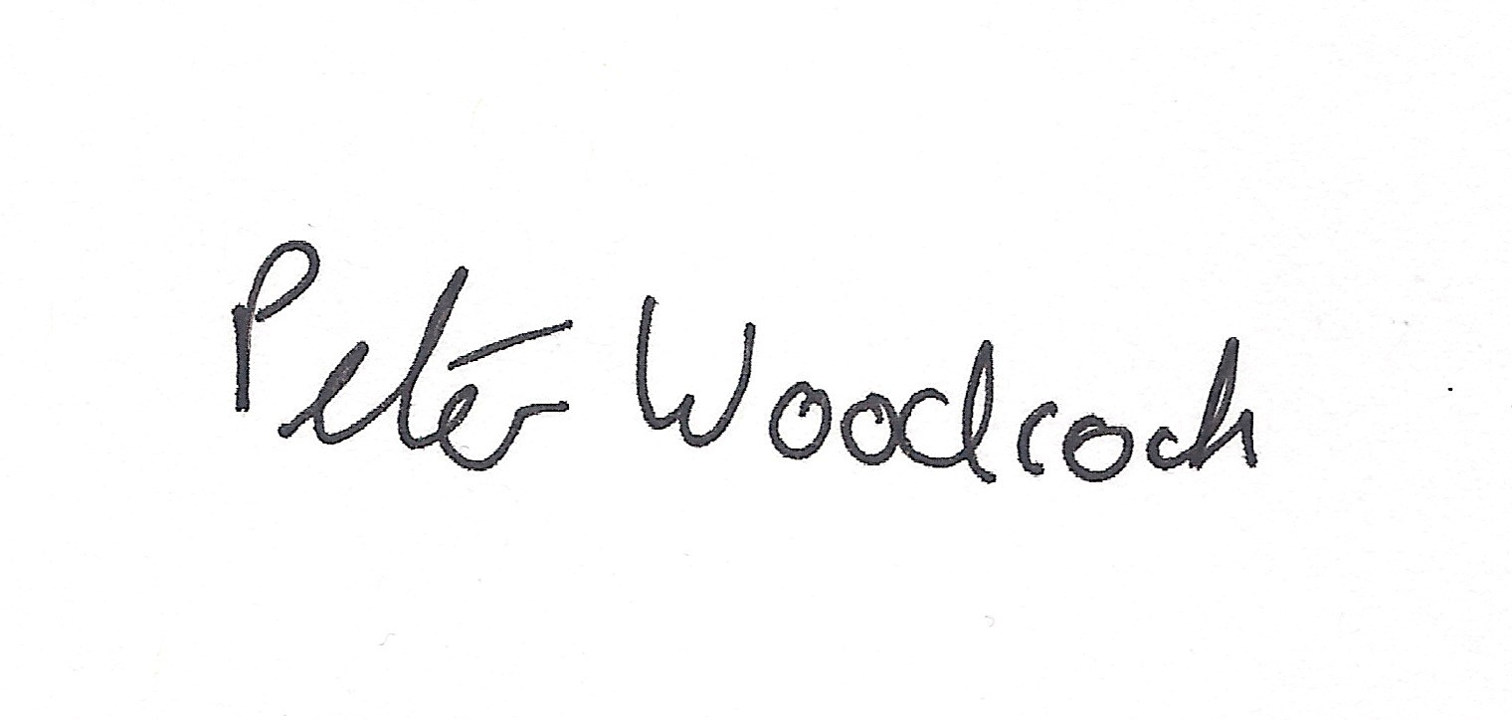
Peter Woodcock | BSc (Hons)
Trainee Planning Manager

Disclaimer

The above consultation response is provided by The Coal Authority as a Statutory Consultee and is based upon the latest available data on the date of the response, and electronic consultation records held by The Coal Authority since 1 April 2013. The comments made are also based upon only the information provided to The Coal Authority by the Local Planning Authority and/or has been published on the Council's website for consultation purposes in relation to this specific planning application. The views and conclusions contained in this response may be subject to review and amendment by The Coal Authority if additional or new data/information (such as a revised Coal Mining Risk Assessment) is provided by the Local Planning Authority or the Applicant for consultation purposes.

