For the Attention of: Caroline Pulley – Case Officer
Merthyr Tydfil County Borough Council

[By Email: planning@merthyr.gov.uk]

21st February 2021

Dear Ms Pulley

PLANNING APPLICATION: P/22/0027

New dwelling; Land To The West Of Gethin House, Newton Street, Abercanaid

Thank you for your consultation notification of 14 February 2022 seeking the views of The Coal Authority on the above planning application.

The Coal Authority is a non-departmental public body sponsored by the Department of Business, Energy & Industrial Strategy. As a statutory consultee, The Coal Authority has a duty to respond to planning applications and development plans in order to protect the public and the environment in mining areas.

The Coal Authority Response: Material Consideration

I have reviewed the site location plans, the proposals and the supporting information submitted and available to view on the LPA website. I can confirm that the site falls within the defined Development High Risk Area.

The Coal Authority records indicate that there is a mine entry and its zone of influence recorded within 20m of the Western site boundary. We hold no treatment details for this feature and its recorded position may be subject to significant departure. Untreated mine entries also pose a potential risk to surface stability and public safety.
This application has been accompanied by a Coal Mining Risk Assessment report (BC/MB/06.19.03.) prepared by Blandford Consulting, dated 23rd July 2019. The report has been based upon a review of mining history and Coal Authority data, and concludes that a recoded mine entry is present within 20m of the Western application boundary.

The report makes recommendations for ground investigations to be carried out on the site in order to discount the presence of the recorded mine within the site and to inform any remedial works and mitigation measures needed to ensure the site is safe and stable. The report’s author also provides further commentary that the proposed dwelling is constructed on a raft foundation to mitigate the risks associated with the untreated mine entry. It is noted that this recorded mine entry is located away from the built development proposed and if it is found to be located within the site would likely be within the edge of the wider garden area.

The intrusive site investigations should be designed and undertaken by competent persons and should be appropriate to assess the ground conditions on the site in order to establish the coal-mining legacy present and the risks it may pose to the development.

The applicant should note that Permission is required from the Coal Authority Permit and Licensing Team before undertaking any activity, such as ground investigation and ground works, which may disturb coal property. Please note that any comments that the Coal Authority may have made in a Planning context are without prejudice to the outcomes of a Permit application.

Mine Gas
It should be noted that wherever coal resources or coal mine features exist at shallow depth or at the surface, there is the potential for mine gases to exist. These risks should always be considered by the LPA. The Planning & Development team at the Coal Authority, in its role of statutory consultee in the planning process, only comments on gas issues if our data indicates that gas emissions have been recorded on the site. However, the absence of such a comment should not be interpreted to imply that there are no gas risks present. Whether or not specific emissions have been noted by the Coal Authority, local planning authorities should seek their own technical advice on the gas hazards that may exist, and appropriate measures to be implemented, from technically competent personnel.

SUDs
We also note that where SUDs are proposed as part of the development scheme consideration will need to be given to the implications of this in relation to the stability and public safety risks posed by coal mining legacy. The developer should seek their own advice from a technically competent person to ensure that a proper assessment has been made of the potential interaction between hydrology, the proposed drainage system and ground stability, including the implications this may have for any mine workings which may be present beneath the site.

The Coal Authority Recommendation to the LPA

This is our recommendation for condition wording, although, we appreciate that you may wish to make some amendment to the choice of words.

1. No development shall commence until;
a) a scheme of intrusive investigations has been carried out on site to establish the risks posed to the development by past coal mining activity; and
b) any remediation works and/or mitigation measures to address land instability arising from coal mining legacy, as may be necessary, have been implemented on site in full in order to ensure that the site is made safe and stable for the development proposed.
The intrusive site investigations and remedial works shall be carried out in accordance with authoritative UK guidance.

2. Prior to the occupation of the development, or it being taken into beneficial use, a signed statement or declaration prepared by a suitably competent person confirming that the site is, or has been made, safe and stable for the approved development shall be submitted to the Local Planning Authority for approval in writing. This document shall confirm the methods and findings of the intrusive site investigations and the completion of any remedial works and/or mitigation necessary to address the risks posed by past coal mining activity.

The Coal Authority therefore do not object to the proposed development subject to the imposition of the above conditions.

Please do not hesitate to contact me if you would like to discuss this matter further.

Yours sincerely,
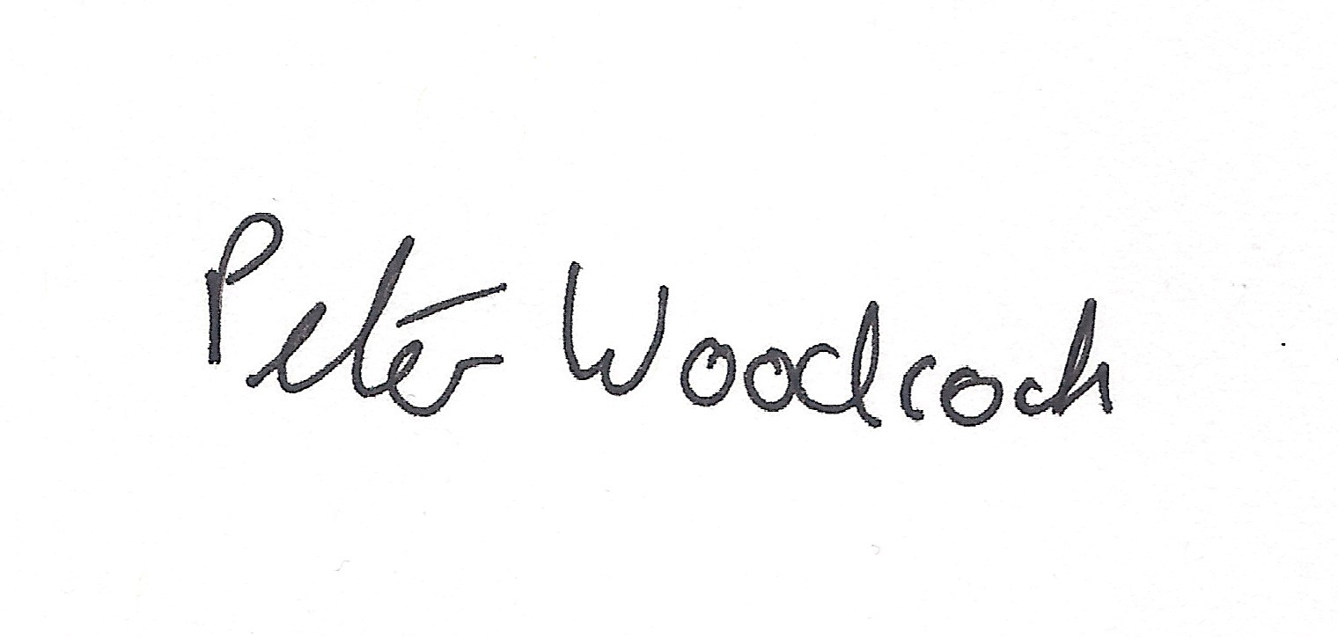

Peter Woodcock | BSc (Hons)
Trainee Planning Manager

General Information for the Applicant

Under the Coal Industry Act 1994 any intrusive activities, including initial site investigation boreholes, and/or any subsequent treatment of coal mine workings/coal mine entries for ground stability purposes require the prior written permission of The Coal Authority, since such activities can have serious public health and safety implications. Failure to obtain permission will result in trespass, with the potential for court action. In the event that you are proposing to undertake such work in the Forest of Dean local authority area our permission may not be required; it is recommended that you check with us prior to commencing any works. Application forms for Coal Authority permission and further guidance can be obtained from The Coal Authority’s website at:www.gov.uk/get-a-permit-to-deal-with-a-coal-mine-on-your-property

Disclaimer

The above consultation response is provided by The Coal Authority as a Statutory Consultee and is based upon the latest available data on the date of the response, and electronic consultation records held by The Coal Authority since 1 April 2013. The comments made are also based upon only the information provided to The Coal Authority by the Local Planning Authority and/or has been published on the Council's website for consultation purposes in relation to this specific planning application. The views and conclusions contained in this response may be subject to review and amendment by The Coal Authority if additional or new data/information (such as a revised Coal Mining Risk Assessment) is provided by the Local Planning Authority or the Applicant for consultation purposes.

In formulating this response The Coal Authority has taken full account of the professional conclusions reached by the competent person who has prepared the Coal Mining Risk Assessment or other similar report. In the event that any future claim for liability arises in relation to this development The Coal Authority will take full account of the views, conclusions and mitigation previously expressed by the professional advisers for this development in relation to ground conditions and the acceptability of development.

